

An Asian Barometer Conference on
The State of Democratic Governance in Asia

Organized by

Program for East Asia Democratic Studies, Institute for Advanced Studies in Humanities and Social Sciences, NTU

Co-sponsored by

The Asia Foundation

Institute of Political Science, Academia Sinica

June 20-21, 2008
Taipei

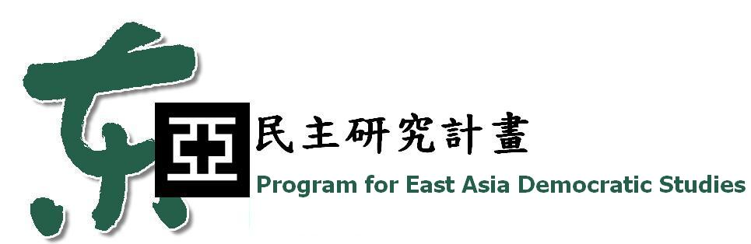
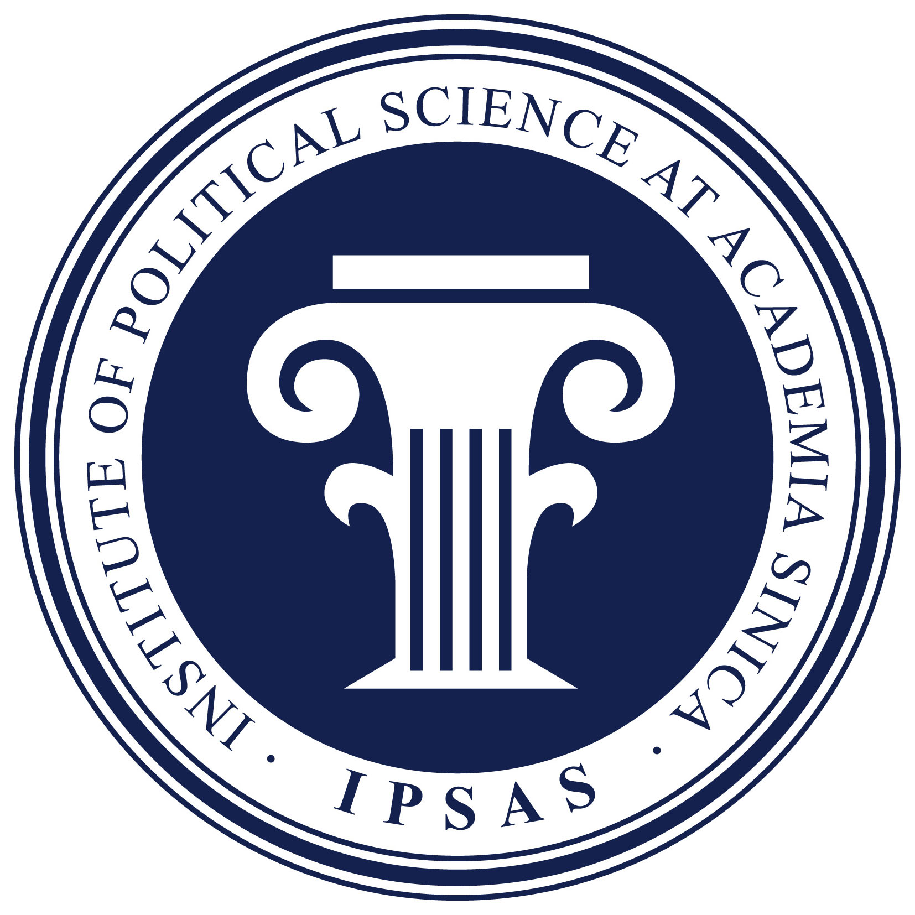

Preliminary Agenda
June 19
All Day Arrival of out-of-town participants
19:00-21:00 Welcome Perception
Caesar Park Hotel Taipei

June 20
08.30-09.00 Registration, Room 101, School of Public Health, National Taiwan University

09.00-09.15 Welcome Remarks
Tzong-he Bau, Vice President of NTU
Gordon Hein, The Asia Foundation
Yu-shan Wu, IPSAS, Academia Sinica
Yun-han Chu, Asian Barometer Survey

09.15-10.45 Session I. A Historical and Theoretical Overview
Moderated by Andrew Nathan, Columbia University
1. A Historical and Comparative Account of Democratization in Asia
Doh Chull Shi, University of Missouri
2. Quality of Democratic Governance and Regime Legitimacy
Yun-han Chu (NTU), Larry Diamond (Hoover Institution), Yutzung Chang and Min-hua Huang (NTU)
Discussants: 1. Hong Yung Lee, UC Berkeley
2. William Cole, TAF

10.45 - 11.00 Coffee Break

11.00 - 12.40 Session II. Democratic Regimes in Northeast Asia
Moderated by Gordon Hein, TAF
1. The State of Democratic Governance in Japan
Masahiro Yamada, Kwansei-Gakuin University
2. The State of Democratic Governance in South Korea
Chong-min Park, Korea University
3. The State of Democratic Governance in Taiwan
Min-hua Huang (NTU), Chang-yan Tsai (National Taiwan Normal University) and Yutzung Chang (NTU)
Discussants: 1. Ji-wen Lin, IPSAS
2. Allen Choate, TAF

12.40-14.20 Lunch

14.20-16.00 Session III. Young Democracies in Southeast Asia
Moderated by Michael Hsiao, Academia Sinica
1. The State of Democratic Governance in the Philippines
Segundo Romero (University of Philippines) and Linda Luz Guerrero (Social Weather Stations)
2. The State of Democratic Governance in Thailand
Robert Albritton (University of Mississippi) and Thawilwadee Bureekul (King Prajadhipok’s Institute)
3. The State of Democratic Governance in Indonesia
Saiful Mujani, Lembaga Survei Indonesia
Discussants: 1. Steven Rood, TAF
2. James Klein, TAF
3. Robin Bush, TAF

16:00-16:15 Coffee Break

16:15-17:55 Session IV. Dominant One-Party Regime and City State
Moderated by Allen Choate, TAF
1. The State of Democratic Governance in Malaysia
Bridget Welsh (Johns Hopkins University), Ibrahim Suffian (Merdeka Centre), and Andrew Aeria (Universiti Malaysia Sarawak)
2. The State of Democratic Governance in Singapore
Eer-Ser Tan (National Singapore University) and Zhengxu Wang (University of Nottingham)
3. The State of Democratic Governance in Hong Kong
Ma Ngok and Kin-man Chan, Chinese University of Hong Kong
Discussants: 1. Anthea Mulakala, TAF
2. Andrew Nathan, Columbia University

* * * * *

June 21
09.00-09.30 Registration
09.30-11.10 Session V Transition from Socialism
Moderated by Doh Chull Shin, University of Missouri
1. The State of Democratic Governance in Mongolia
Damba Ganbat, Political Education Academy
2. The State of Democratic Governance in Cambodia
Dorie Meerkerk, Center for Advanced Study
3. The State of Democratic Governance in Vietnam
Pham Thanh Nghi, Institute of Human Studies
Discussants: 1. William Infante, TAF
2. Nicole Sayres, TAF
3. Robert Albritton, University of Mississippi

11:10-11:25 Coffee Break

11.25-12.45 Session VI South Asia
Moderated by Wen-cheng Lin, Taiwan Foundation for Democracy
1. The State of Democratic Governance in India
K. C. Suri, University of Hyderabad
2. The Quality of South Asian Democracies: An Overall Assessment
K. C. Suri (University of Hyderabad), Yogendra Yadav (Center for the Study of Developing Societies), Suhas Vasant Palshikar(University of Pune), and Sandeep Shastri(International Academy for Creative Teaching)
Discussants: 1. Anthea Mulakala, TAF
2. Larry Diamond, Hoover Institution

12.45-14.00 Lunch

14.00-15.15 Session VII Synthetic Analysis
Moderated by Larry Diamond, Hoover Institution
1. The quality of East Asian democracies: An overall assessment
Doh Chull Shin, University of Missouri
2. Political Values and Regime Evaluation
Yutzung Chang (NTU), Alex Chang (IPSAS) and Yun-han Chu (NTU)
Discussants: 1. Bridget Welsh, Johns Hopkins University
2. James Gibson, Washington University

15:15-15.30 Coffee Break

15:30-17.00 Session VIII A Roundtable on Reform Agenda and Policy Implications
Moderator: Gordon Hein, TAF
Panelists: Larry Diamond, Hoover Institution
William Cole, TAF
Andrew Nathan, Columbia University
Yun-han Chu, NTU
James Gibson, Washington University
An Asian Barometer Conference on
The State of Democratic Governance in Asia
時間：2008年6月20日（五）21日（六）
地點：國立台灣大學公共衛生學院101講堂

姓名____________________________服務單位_____________________________

聯絡電話________________________e-mail________________________________

出席場次 □ 6月20日上午 □ 6月20日下午
- 6月21日上午 □ 6月21日下午

是否用餐 □ 素食 □ 葷食 □不用餐

聯絡電話：（02）2357-0427
（02）2351-9641 #675 林先生
網址（報名表下載）：http://eacsurvey.law.ntu.edu.tw/
報名方式：6/13前e-mail至 bombman.lin@gmail.com或 Fax：（02）2357-0420

